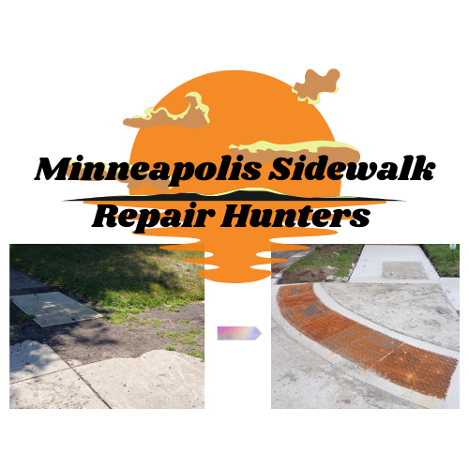
Minneapolis Sidewalk Repair Hunters
msack9@gmail.com Hale Neighborhood, Minneapolis, Minnesota www.mplssrh.org

In Support of Senate File 914 and House File 998 to Enhance Minneapolis’ Walkways and ADA Curb Cuts

{Date}
Dear Senator {Their Last Name} or Representative {Their Last Name},

As a member of the Minneapolis Sidewalk Repair Hunters, I am in full support of SF 914 and HF 998. This bill would provide $10 million to help Minneapolis further their Americans with Disabilities Act (ADA) Transition Plan, enhance pedestrian safety by updating ADA curb cuts for current compliance, and install Accessible Pedestrian Signals (APS) and modifications.
According to the 2021 United States Census, the city of Minneapolis has the largest population of residents in the state living with a disability at 50,893, which is 12% of the city’s total occupants; St. Paul is second with 37,356 residents who have some kind of impairment. This legislation is absolutely necessary to increase safety and enhance accessibility in the City of Lakes to make everyone feel welcome and have features available to make daily living more equitable.
Having smooth curb cuts greatly benefits those who use wheelchairs, other mobility devices, strollers, and bikes, as well as every pedestrian. It would provide fair access, independence, and safety to individuals who must rely on cut outs every single day to get to work, recreational activities, or wherever their destination may be.
During the last decade or so, Minneapolis has been installing new ADA-regulation curb cuts and making their crosswalks more accessible for pedestrians who use wheelchairs, are blind, or are hard of hearing. The Minneapolis Sidewalk Repair Hunters approve of the revamped designs, and would ultimately like to see the city revamp every curb cut and street crossing to increase access for everyone.
Therefore, I graciously ask you for your support of this important bill to ensure its passage this legislative session. The time is now to improve our sidewalks and crosswalks to create equal access to every sidewalk user.

Thank you,
{Your Name}
Member, Minneapolis Sidewalk Repair Hunters

Minneapolis Sidewalk Repair Hunters is a community-led movement to locate and report inadequate sidewalks and curb cuts that impede access and safety to those who use wheelchairs, other mobility devices, strollers, and bikes, as well as every pedestrian.

